Example Sign: ‘Restricted Carcinogen in Use’, Using GHS Label Elements

DANGER

RESTRICTED CARCINOGEN
IN USE

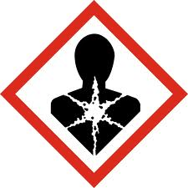 |  | 